Native

American

Tribes

Of

North

America

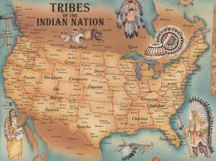

Kelli Cole
CUR 513
11/1/12

Apache

How do you pronounce the word "Apache"? What does it mean?

It's pronounced "uh-PAH-chee." It means "enemy" in the language of their Zuni neighbors. The Apaches' own name for themselves was traditionally Nde or Ndee (which means "the people"), but today most Apache people use the word "Apache" themselves, even when they are speaking their own language.

Where do the Apaches live?
The Apache are natives of the Southwest deserts. Some Apache people were also located across the border in northern Mexico.

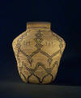

Apache ollas ("olla" pronounced "oy-yuh”, a Spanish word meaning jars with a neck and mouth and in Indian art collecting is used to describe such forms in both basketry as well as pueblo pottery) come in many forms -- some of the finest are an idealized human torso form with a base, shoulders, neck and "mouth".

The Plains Apaches are still living in Oklahoma today. Some Apaches from other bands were captured and sent to live in Oklahoma by the Americans in the 1800's, while other Apaches resisted being moved and remain in Arizona and New Mexico today. The total Apache Indian population today is around 30,000.

Arapaho

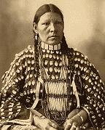

How do you pronounce the word "Arapaho"? What does it mean?
It's pronounced "Uh-RAH-puh-hoe," but nobody's sure exactly what it means. It may be a corruption of the Pawnee word for 'traders.' The Arapahos call themselves Hinono-eino or Inuna-ina, which means "our people," but today they also use the word Arapaho (sometimes spelled Arapahoe.)

Where do the Arapahos live?

The Arapahos were far-ranging people, especially once they acquired horses. By the time the Americans met them they were living on the Great Plains in what is now Colorado, Wyoming, Nebraska and Kansas. Eventually the US government deported the Southern Arapaho tribe to Oklahoma, where they joined together with the Cheyenne. The Northern Arapaho tribe remains in Wyoming today.

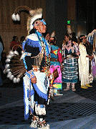

Blackfoot

Is the name of the tribe "Blackfoot" or "Blackfeet"? Where did this name come from?
"Blackfoot" is the English translation of the word siksika, which means, "black foot." It refers to the dark colored moccasins the people wear. Some Blackfoot people are annoyed by the plural "Blackfeet," which is obviously an Anglicization. But most Blackfoot people accept both terms. "Blackfoot" is more commonly used in Canada, and "Blackfeet" is more commonly used in the United States.
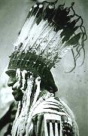

Where do the Blackfeet Indians live?
The Blackfeet Indians are original residents of the northern Plains. Most Blackfoot people still live in this region today.

What language do the Blackfeet speak?
Most Blackfoot Indians speak English today, but about half of them also speak their native Blackfoot language.

Cherokee
How do you pronounce the word "Cherokee"? What does it mean?
It's pronounced "CHAIR-uh-kee." It comes from a Muskogee word meaning 'speakers of another language.' Cherokee Indians originally called themselves Aniyunwiya, "the principal people," but today they accept the name Cherokee, which is spelled and pronounced Tsalagi in their own language.

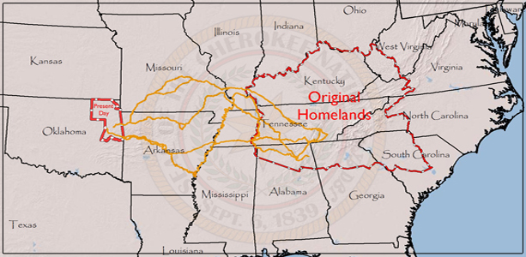
Where do the Cherokee Indians live?
The Cherokees are original residents of the American southeast region, particularly Georgia, North and South Carolina, Virginia, Kentucky, and Tennessee. Most Cherokees were forced to move to Oklahoma in the 1800's along the Trail of Tears. Descendants of the Cherokee Indians who survived this death march still live in Oklahoma today. Some Cherokees escaped the Trail of Tears by hiding in the Appalachian hills or taking shelter with sympathetic white neighbors. The descendants of these people live scattered throughout the original Cherokee Indian homelands.

Rabbit (Jisdu, Tsisdu, Chisdu, Jistu, Tsistu, etc.): Rabbit is the trickster figure in the folklore of the Cherokee and other Southeastern tribes.

Chinook

How do you pronounce the word "Chinook"? What does it mean?
It's pronounced "chih-nook." This is an English pronunciation of the Salishan place name Tsinuk, which was also the name used for the Chinook Jargon trade language.

Where do the Chinooks live?
The Chinook Indians are original people of the Pacific Northwest Coast. They live in Washington state.

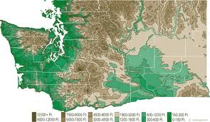

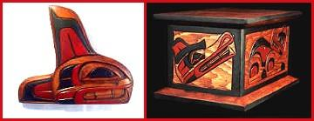

Sa-Cinn Indian Carvings

Traditional American Indian woodcarvings from Northwest Coast and other First Nations artists. Masks, bentwood boxes, staves, wooden figurines, wall hangings, and more.

What was Chinook transportation like in the days before cars? Did they paddle canoes?
Yes--the Chinook Indian tribe made large dugout canoes by hollowing out cedar or fir logs. The Chinook tribe used these canoes to travel up and down the seacoast for trading, fishing and hunting, and warfare.
Choctaw
How do you pronounce the word "Choctaw"? What does it mean?
It's pronounced "CHOCK-taw." It comes from their own tribal name, Chahta, which was the name of a legendary Choctaw leader.
Where do the Choctaws live?
The Choctaws are original people of the American southeast, particularly Mississippi, Alabama, Louisiana, and Florida. Most Choctaws were forced to move to Oklahoma in the 1800's along the Trail of Tears. Their descendants live in Oklahoma today. Some Choctaws escaped by hiding or pretending to be white, and descendants of these people are still living in the original Choctaw homelands.
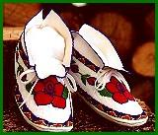
Fancier and more expensive than moccasin slippers, beaded moccasins are usually used by contemporary Native Americans as regalia for ceremonies, powwows, and special occasions like weddings.
What was the Trail of Tears?
Trail of Tears was the Choctaw and Cherokee name for what the Americans called Indian Removal. During the 1800's, the US government created an "Indian Territory" in Oklahoma and sent all the eastern Native American tribes to live there.
Dakota

What is the difference between the Lakota and Dakota Sioux? What do these words mean?
There is no real difference. "Lakota" and "Dakota" are different pronunciations of the same tribal name, which means "the allies." One Sioux dialect has the letter "L" in it, and the other dialect does not. This is only a pronunciation difference, not a political one. Of the 13 Sioux political subdivisions, seven pronounce the word "Lakota," four pronounce it "Dakota," one pronounces it "Nakota," and one is split between pronouncing it "Dakota" and "Nakota." But they all consider themselves part of the same overall culture.

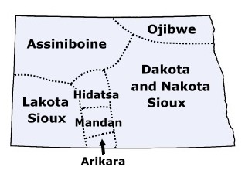

Where do the Dakota people live?
The original Dakota homelands were in what is now Wisconsin, Minnesota, and North Dakota and South Dakota. The Dakotas traveled freely, however, and there was also significant Dakota presence in the modern states of Iowa, Nebraska, Montana, and northern Illinois, and in south-central Canada.

Gros Ventre

How do you pronounce the name "Gros Ventre"? What does it mean?
It's pronounced "Grow Vaunt." That means "big belly" in French. Some people think they got this name because they enjoyed feasting. Others think the French saw a Gros Ventre rub his belly as a gesture from the Plains Indian sign language. Or they could have confused the Gros Ventres with another tribe, the Hidatsa, who the French also called "Gros Ventre." In their own language, the Gros Ventres call themselves Aane or A'aninin, which means "white clay people." They are also known as the Atsina, which is the Arapaho name for their tribe. Where do the Gros Ventres live?
The Gros Ventres were far-ranging people, especially once they began riding horses. When the Americans met them, the Gros Ventre tribe was living in Montana. Most Gros Ventre descendants still live in Montana today.
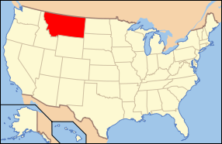

What kinds of stories do the Gros Ventres tell?
There is lots of traditional Gros Ventre legends and fairy tales. Storytelling is very important to the Gros Ventre Indian culture.

Hopi

How do you pronounce the word "Hopi"? What does it mean?
It's pronounced "hope-ee," and it means "peaceful person" or "civilized person" in the Hopi language.

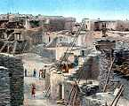Adobe houses (also known as pueblos) are Native American house complexes used by the Pueblo Indians of the Southwest. Adobe pueblos are modular, multi-story houses made of adobe (clay and straw baked into hard bricks) or of large stones cemented together with adobe. Each adobe unit is home to one family, like a modern apartment. The whole structure, which can contain dozens of units, is often home to an entire extended clan.

Where do the Hopis live?
The Hopi are natives of northwestern Arizona, where they and their ancestors have been living for thousands of years.

How is the Hopi Indian nation organized?
The Hopis live on a reservation, which is land that belongs to them and is under their control. The Hopi Nation has its own government, laws, police, and services, just like a small country.

Illini
How do you pronounce "Illini?" What does it mean?
Illini is pronounced "ih-LIE-nee," and Illinois is pronounced "ih-lih-NOY" (like the state, which is named after the tribe.) They are both European adaptations of the Illinois Indians' original word for themselves, Illiniwek (pronounced "ih-lih-new-eck,") that means "the best people."

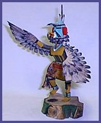

Kachinas are not actually dolls the way the word is usually used; they are wooden sculptures, religious in nature, which are not used as or appropriate for children's toys.

Where do the Illinois Indians live?
The Illini were original inhabitants of modern-day Illinois, Indiana, Missouri, and Iowa. The Illini tribe was nearly wiped out by war in the 1700's, and the survivors had to move to Kansas and Oklahoma. The Peoria Tribe of Oklahoma is made up of original Illinois Indians.

What were Illini homes like in the past?
The Illinis didn't live in tepees. They lived in villages of large rectangular houses with walls made of woven reeds. Today, Native Americans only build a reed house for fun or to connect with their heritage, not for shelter.

Kickapoo
How do you pronounce the word "Kickapoo"? What does it mean?
It's pronounced "KICK-a-poo." It comes from a Shawnee word for "wanderer." In Mexico the tribal name is spelled Kikapu, which is the Spanish way of representing the same pronunciation. Sometimes it is also spelled Kikapoo.

Where do the Kickapoos live?
The Kickapoo Indians originally lived in the Michigan and Ohio area. They fled south and west to get away from British and American aggression, settling briefly in Indiana, Illinois and Wisconsin.

Eventually the Americans forced some Kickapoos onto Kansas and Oklahoma reservations. Others escaped, and their descendants now live in Texas and northern Mexico. Few Kickapoos still live in their original homeland.
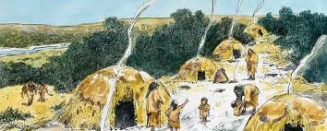

What were Kickapoo homes like?
The Kickapoos didn't live in tepees. They lived in small dome-shaped houses called wickiups.

Kickapoo Indians in Mexico still live in traditional homes like these today, but most American Kickapoos live in modern houses and apartment buildings now.
Lakota

What is the difference between the Dakota and Lakota Sioux? What do these words mean?
There is no real difference. "Lakota" and "Dakota" are different pronunciations of the same tribal name, which means "the allies." One Sioux dialect has the letter "L" in it, and the other dialect does not. This is only a pronunciation difference, not a political one. Of the 13 Sioux political subdivisions, seven pronounce the word "Lakota," four pronounce it "Dakota," one pronounces it "Nakota," and one is split between pronouncing it "Dakota" and "Nakota." But they all consider themselves part of the same overall culture.

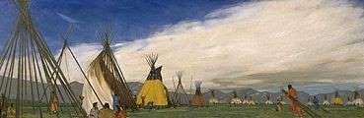
Tepees (also spelled Teepees or Tipis) are tent-like American Indian houses used by Plains tribes. A tepee is made of a cone-shaped wooden frame with a covering of buffalo hide. Like modern tents, tepees are carefully designed to set up and break down quickly. As a tribe moved from place to place, each family would bring their tipi poles and hide tent along with them. Originally, tepees were about 12 feet high, but once the Plains Indian tribes’ acquired horses, they began building them twice as high.

Makah

How do you pronounce the word "Makah"? What does it mean?
It's pronounced "muh-kaw." This is an English pronunciation of a neighboring tribe's name for them, which means "generous ones." Their own name for themselves is longer and harder to pronounce, Qwiqwidicciat (which means "people of the point.")

Where do the Makahs live?
The Makah Indians are original people of the Pacific Northwest Coast. They live in Washington state.
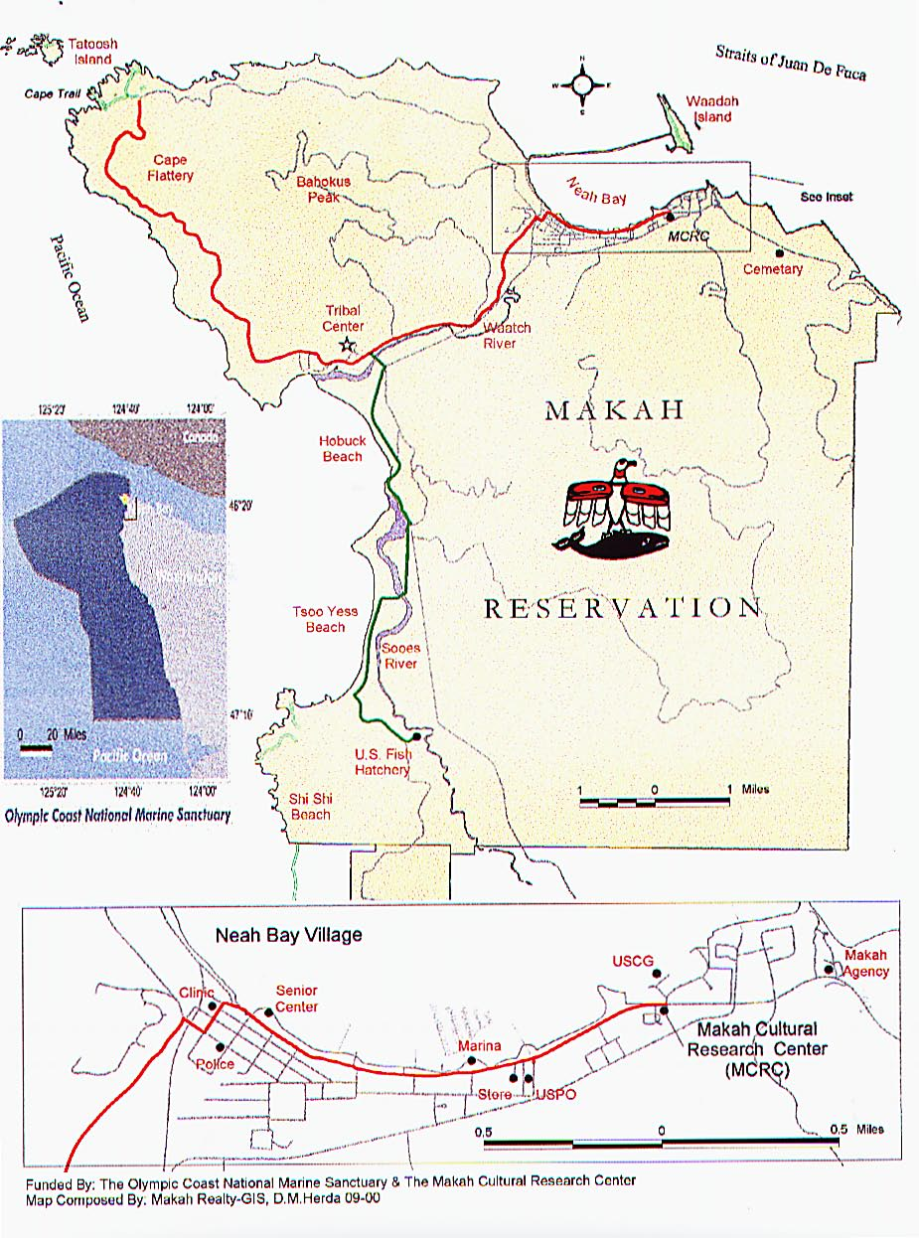
How is the Makah Indian nation organized?
The Makahs live on a reservation, which is land that belongs to them and is under their control. The Makah Nation has its own government, laws, police, and services, just like a small country. In the past, its own local chief or headman, who was always a high-ranking clan leader, led each Makah village.
Mohawk
How do you pronounce the word "Mohawk"? What does it mean?
It's pronounced, "mo-hawk." It comes from a name their Algonkian enemies used to call them, meaning "man-eaters." In their own language, the Mohawk people call themselves Kanienkehaka, which means "people of the flint."

Were they really man-eaters?
It's not clear anymore whether that name was supposed to be literal, or an insult, or just a figure of speech to show that the Mohawks were fierce. Some Mohawk people believe that in ancient times, before they joined the Iroquois Confederacy, their ancestors used to eat enemies they had killed in battle. Other Mohawks think that never really happened and cannibals were always rare and strange in Mohawk society, like they were in other cultures.
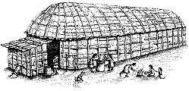
Where do the Mohawks live?
The Mohawks are original people of New York state. Some Mohawk people still live in New York today, but most Mohawks retreated to Canada in the 1700's.

The Mohawk people lived in villages of longhouses, which were large wood-frame buildings covered with sheets of elm bark.
Navajo
How do you pronounce the word "Navajo"? What does it mean?
It's pronounced "NAH-vuh-ho." This spelling came from Spanish-- you can sometimes see the same name spelled "Navaho" instead. It comes from a Pueblo Indian word for "planted fields" or "farmlands." The Pueblo Indians probably gave them this name because unlike their relatives the Apaches, the Navajos were farmers who lived in settled villages. Traditionally the Navajos called themselves Dine'é or just Diné (which means "the people"), but today most Navajo people also use the word "Navajo" themselves, especially when they are speaking English.
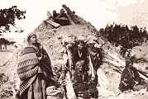
What were Navajo homes like in the past?
Navajo people lived in hogans, which are traditional earth houses. A hogan is made of a special wood framework packed with clay into a domed shape, with the door facing east. The thick earthen walls insulate the hogan and protect the people inside from wind and strong weather.
Today, most Navajo people live in modern houses and apartment buildings, just like you. However, hogans are still built and used for religious and cultural purposes.
Ottawa

How do you pronounce 'Ottawa'? What does it mean?
It's pronounced "AH-ta-wa," the same as the city in Canada (which was named after them.) It is spelled Odawa in their native language, and it means "traders." The Ottawa people call themselves Anishinabe in their own language, which means 'original person.'

Where do the Ottawas live?
Most Ottawa Indian people live in their original homeland in southern Ontario and Michigan state. Other Ottawas were deported to Oklahoma by the US government, and some Ottawas assimilated into Ojibway bands. There are about 15,000 Ottawa Indians today.

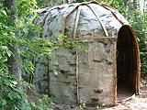

What were Ottawa homes like in the past?
Ottawa people didn't live in tepees. They lived in villages of birchbark houses called waginogan, or wigwams.

Today, Native Americans only build a wigwam for fun or to connect with their heritage. Most Ottawas live in modern houses and apartment buildings, just like you.

Pawnee
How do you pronounce the word "Pawnee"? What does it mean?
It's pronounced "paw-nee." This was an English form of the Sioux name for the tribe.

Where do the Pawnees live?
The Pawnee Indians are original people of Nebraska and Kansas. The Pawnee tribe was forced to move to a reservation in Oklahoma during the 1800's, and most Pawnee people are still living in Oklahoma today.
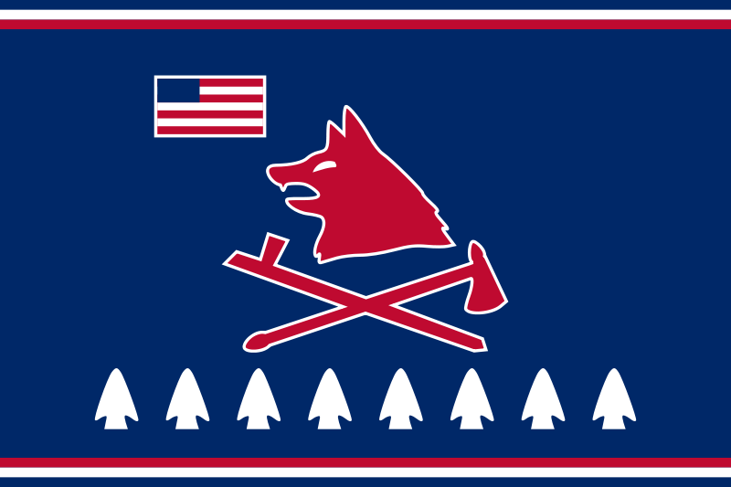

What were Pawnee homes like in the past?
Most Pawnee Indians lived in settled villages of round earthen lodges. Pawnee lodges were made from wooden frames covered with packed earth. When the Pawnee tribe went on hunting trips, they used buffalo-hide tipis (or teepees) as temporary shelter, similar to camping tents.
What were men and women's roles in the Pawnee tribe?
Pawnee men were hunters and sometimes went to war to protect their families. Pawnee women were farmers and also did most of the childcare and cooking. Only men became Pawnee chiefs, but both genders took part in storytelling, artwork and music, and traditional medicine.
Quapaw

How do you pronounce the word "Quapaw"? What does it mean?
It's pronounced, "quaw-paw." It comes from their own tribal name, which means "downstream people." The Quapaws have also been known as the Alkansea or Arkansas Indians after a tribal town named Acansa, which meant "southern." That is where the name of the state of Arkansas came from.

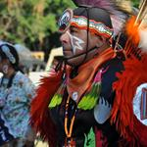

Where do the Quapaws live?
The Quapaw Indians are original people of Arkansas, Missouri, Mississippi, and Tennessee. The Quapaw tribe was forced to move to Oklahoma in the 1800's along with many other tribes, and most Quapaw people are still living in Oklahoma today.

What was Quapaw food like in the days before supermarkets?
The Quapaws were farming people. Quapaw women worked together to raise crops of corn, beans, and squash. Men hunted deer and small game, fished in the rivers, and took part in seasonal buffalo hunts.

Seminole

How do you pronounce the word "Seminole"? What does it mean?
It's pronounced "SEH-minn-ole." It comes from a Spanish word meaning "wild."

How did the Seminole tribe form?
In the 1700's, many Indians from Georgia and Florida tribes--Creeks, Miccosukees, Hitchitis, and Oconees--joined together for protection. These tribes originally had unique cultural identities, but they soon merged into a unified Seminole nation. Over the next century, Native Americans from other tribes and African-Americans who escaped from slavery crossed the border into Florida to join the Seminoles too.

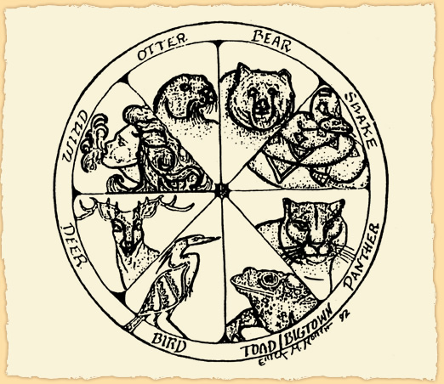
Clans
Each Seminole Indian born of a Seminole mother is a member of her "Clan" - a traditional extended family unit. Husbands traditionally went to live in the wife's clan camp. Each clan is characterized by a non-human entity with which is shares many traits, such as strength, courage, or endurance. There are eight Seminole clans - Panther, Bear, Deer, Wind, Bigtown, Bird, Snake, and Otter.

Where do the Seminoles live?
The Seminoles lived in Florida. They started out in northern Florida, but when the Americans attacked them, the Seminole tribe retreated further south, into the Everglades.

Seneca

How do you pronounce the word "Seneca"? What does it mean?
It's pronounced "SEH-neh-kah." It comes from the name of one of their villages, Osininka. In their own language, the Senecas call themselves Onandowaga, which means "people of the mountain."
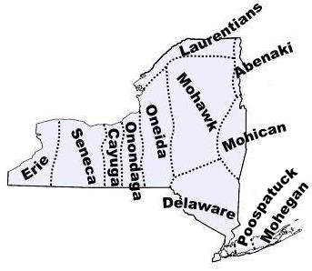
Where do the Seneca Indians live?
The Senecas originally lived in New York state. Many Seneca people still live in New York today, but others were forced to migrate to Oklahoma or Canada.
What were men and women's roles in the Seneca Indian tribe?
Seneca men were in charge of hunting, trading, and war. Seneca women were in charge of farming, property, and family. These different roles were also reflected in Seneca government. Women always ruled Seneca clans, who made the land and resource decisions for each clan. But the chiefs, who made military decisions and trade agreements, were always men. Only men represented the Seneca Nation at the Iroquois Great Council, but only women voted to determine whom the Seneca representatives would be.
Tonkawa

How do you pronounce the word "Tonkawa"? What does it mean?
It's pronounced "tong-kuh-wah." It may have come from a word meaning "they keep together" in the language of their Wichita neighbors, but this isn't certain.

Where do the Tonkawas live?
The Tonkawa Indians are original people of Texas. The Tonkawa tribe was forced to move to Oklahoma in the 1800's along with many other tribes, and most Tonkawa people are still living in Oklahoma today.

What was Tonkawa food like in the days before supermarkets?
The Tonkawas were big game hunters. Tonkawa men hunted buffalo and deer and sometimes fished in the rivers. The Tonkawas also collected roots, nuts, and fruit to eat. Though the Tonkawas were not farmers, corn was also part of their diet. They got corn by trading with neighboring tribes.

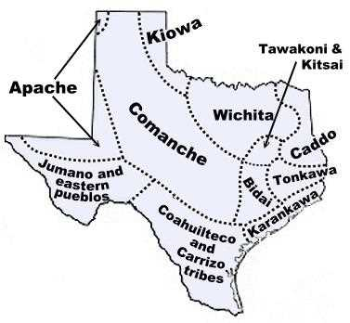

Ute

How do you pronounce the word "Ute"? What does it mean?
It is pronounced "yoot" (rhymes with "boot.") This comes from the Spanish name for the tribe, Yuta, but nobody knows for sure where the Spanish word came from. It is not true that it means "mountain" in the Ute language. Maybe it was a Spanish corruption of the tribe's own name for themselves, Nuutsiu, which means "the people." Or maybe it came from the Western Apache word yudah, which means "high up."

Where do the Utes live?
The Ute Indians were far-ranging people. Different bands of Ute Indians lived in what is now Colorado, Utah, New Mexico, and Nevada. Most Ute people still live in these areas today.
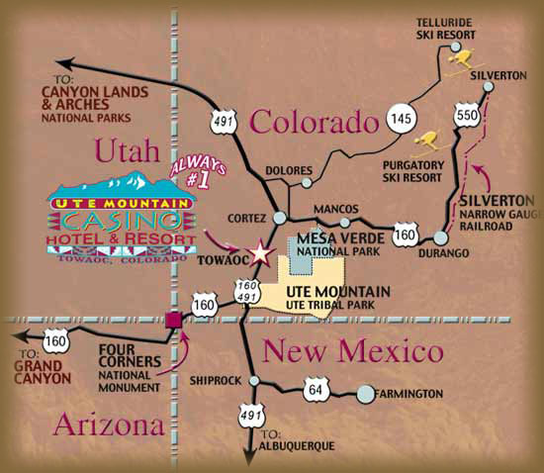

What was Ute food like in the days before supermarkets?
The Utes were hunter-gatherers, and moved from place to place frequently as they gathered food for their families. Ute men hunted deer, elk, buffalo, and small game. Ute women gathered roots, pine nuts, seeds and fruits.

Wampanoag

What is the correct pronunciation of "Wampanoag?" What does it mean?
Wampanoag means "easterners." Originally it was pronounced similar to WAWM-pah-NAW-ahg. But today, most Wampanoag people pronounce the name either wamp-a-NO-ag or WAMP-ah-nog ("wamp" rhymes with "stomp.")

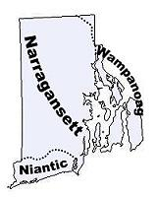

Where do the Wampanoag Indians live?
The Wampanoag Indians were original natives of Massachusetts and Rhode Island. It was Wampanoag people who befriended the pilgrims at Plymouth Rock and brought them corn and turkey for the famous first Thanksgiving. Unfortunately, the relationship went downhill from there, and disease and British attacks killed most of the Wampanoag people. The surviving Wampanoags are still living in New England today.

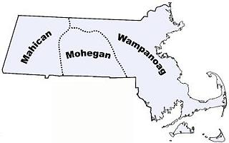
Wappinger

How do you pronounce "Wappinger?" What does it mean?
It's pronounced "WAH-pin-jer." Some people think this name might have come from the Algonquian word Waban, meaning "dawn" or "east," but according to historical records it actually comes from the word Wapinkw, which means "opossum people." The Dutch, who always use this ending to refer to people’s nationalities, added English speakers softened the -er ending and the g later.

Were the Wappingers part of the Mohican tribe?
Not originally. They spoke related languages and shared similar cultures, but the Wappinger and Mohican used to be distinct tribes, each with its own leadership
But after Europeans arrived, many Native American people of the east coast died from disease and warfare. The survivors merged together, and many of their original tribal distinctions were lost. This happened to the Wappingers and Mohicans.

Yakama

How do you pronounce the word "Yakama"? What does it mean?
It's pronounced "yeah-kuh-mah." In the past, it was often spelled Yakima (like the city in Washington State that was named after them), but the Yakama tribe prefers the spelling with a. No one is entirely sure where this name came from. It may have been an English corruption of the Yakama word for "pregnant women," "family," or "runaway." Their own name for themselves was Waptailmim, which means "people of the narrow river."

Where do the Yakamas live?
The Yakama Indians are original people of the Northwest. They live in Washington state.
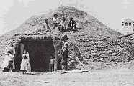

What were Yakama homes like in the past?
The Yakamas lived in villages of earth lodges sometimes known as "pit houses." These homes are built partially underground, with a basement-like living space dug from the ground and a dome-shaped wooden frame built over it and packed with earth. These lodges were small (about 15 feet across) and only a single family lived in each one.

Zuni

How do you pronounce the word "Zuni"? Where does it come from?
In Spanish, it was spelled Zuñi and pronounced "zoon-yee." In English, it is usually spelled Zuni and pronounced "zoo-nee." The Spanish borrowed this name from a Keres Pueblo name for the Zuni Pueblo. In their own language, the Zunis call themselves Ashiwi, which means "the flesh people." But today most Zuni people also use the word "Zuni" themselves, especially when they are speaking English.
Where do the Zunis live?
The Zuni are natives of New Mexico. Unlike many Native American tribes, the Zuni Indians were never forced to leave their homelands and are still living there today.
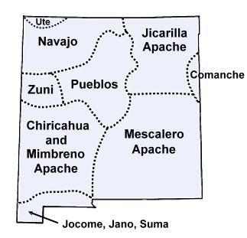

What were men and women's roles in the Zuni tribe?
Generally, Zuni women were in charge of the home and family. Zuni clans are matrilineal, which means Zuni people trace their family through their mothers. Zuni men were in charge of politics, agriculture and war.

